Monday | 20 minutes of Reading- Read “Plant Song” mini book  20 minutes of Writing Word work - Illustrate your poem. Use dialogue, speech and thought bubbles. Make your characters MOVE! Word Work.  20 minutes of Math- Standard Measurement (one lesson daily)
Tuesday | 20 minutes of Reading- Read “Plant Song”  20 minutes of Writing Word work - Read your poem and look for focus letter sounds. Look for the capital and lowercase letters. Identify punctuation, words that rhyme, initial or ending sounds  20 minutes of Math – Standard Measurement (one lesson daily)
Wednesday | 20 minutes of Reading – Read the poem, “Plant Song” and look for all the high frequency words you know. Using a highlighter, underline these words.  20 minutes of Writing/ Word work – Read the poem: sort words and pictures Parts of speech. Word work Newspaper Sort  20 minutes of Math- Standard Measurement (one lesson daily)
Thursday | 20 minutes of Reading- Read the poem, “Plant Song” and cut out the sentences strips and practices putting the poem in the correct order. ”  20 minutes of Writing Word work –– Read the poem, sort words and pictures Parts of speech  20 minutes of Math – Standard Measurement (one lesson daily)
Friday | 20 minutes of Reading- Students can login to RAZ kids and read or pick out a good fit book for your childs reading level.  20 minutes of Writing Word work - Read the poem: sort words and pictures Parts of speech. Read “Plant Song”  20 minutes of Math- Standard Measurement (one lesson daily)
Extras:  DPA | DPA (Daily Physical Activities) provided by Cheryl McIntyre  Yahtzee
Health
Art

Raz Kids login Information
Student login is their first name … except Sofia and she is Sofia O. and their password is also westie
https://www.kidsa-z.com/main/Login

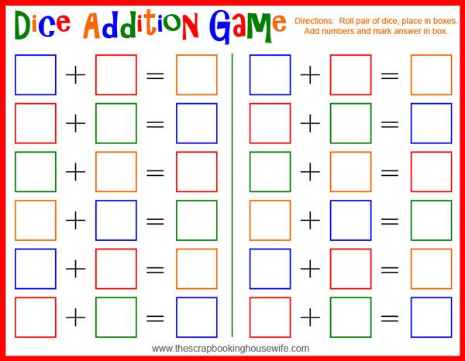

April Kindness Calendar
2020
Sunday | Monday | Tuesday | Wednesday | Thursday | Friday | Saturday
 |  |  | 1 | 2 | 3 | 4
 |  |  | Write a thank you note to someone special. | Draw a picture for a friend or family member. | Let someone else go “first” in your family. | Help make food for your family.
5 | 6 | 7 | 8 | 9 | 10 | 11
Pick up 3 pieces of litter in your community (wash your hands!) | Do a chore for someone in your family. | Teach a family member something that you are good at! | Smile at everyone you see today! | Cheer someone up with a silly face or joke. | Hold the door open for someone in your family. | Tell someone you care about that you love them and why they are special to you.
12 | 13 | 14 | 15 | 16 | 17 | 18
Call a family member on the phone/I-pad. | Read a book to someone. | Make someone’s bed for them. | Give everyone you see or meet a compliment today. | Take the day to not complain about anything. | Reduce your water and electricity use today. | Be a good listener.
19 | 20 | 21 | 22 | 23 | 24 | 25
Reuse old socks to make funny sock puppets. Put on a show for your parents. | Clean up someone else’s mess. | Write a kind chalk message on the sidewalk or deliver your neighbor a picture. | Do something kind for the Earth (plant a seed, make a bird house, clean up garbage, etc). | Make a family member breakfast in bed. | Offer help to someone. | Take the time to appreciate a sunset/sunrise with someone you love.
26 | 27 | 28 | 29 | 30
Clean up your room or another room in the house without being asked | Make a thank you sign for sanitation workers when they come to pick up your garbage/  recycling. | Write a letter to a soldier overseas or a veteran. | Be kind to yourself today! | Learn hello in another language.

